Chapter 4

# Try It Yourself: Associate Two Categorical Variables

## Excel Instructions

1. Open videogames.csv in Excel.
2. Insert a pivot table:
   1. Highlight Columns A:P by selecting them simultaneously.
   2. From the Excel ribbon at the top, Click Insert→PivotTable.
   3. 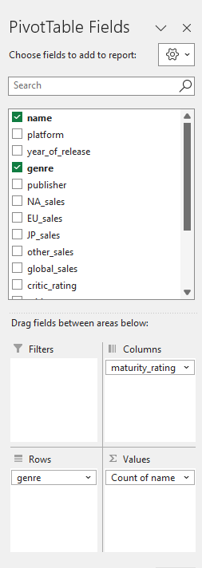Your settings should be as follows:
      1. For Table/Range: videogames!$A:$P
      2. Select “New Worksheet.”
   4. Click OK
3. Configure the pivot table using the PivotTable Fields box to the right.
   1. Drag genre to Rows.
   2. Drag maturity_rating to Columns.
   3. Drag name to Values. Keep the default of “Count of name.”
4. Filter the genre variable to include only “Sports,” “Action,” “Shooter,” and “Role-Playing.”
   1. Click the dropdown arrow of “Row Labels” in cell A4.
   2. A list of all unique values for genre will appear.
   3. Uncheck the “Select All” option to clear all selections.
   4. Scroll through the list and find “Sports,” “Action,” “Shooter,” and “Role-Playing,” and check the boxes next to each.
   5. Click “OK” or press “Enter.”
   6. After applying the filter, only the rows where “genre” equals “Sports,” “Action,” “Shooter,” and “Role-Playing” will be displayed.
5. Filter the maturity_rating variable to include only “E,” “M,” “T,” and “E10+.”
   1. Click the dropdown arrow of “Column Labels” in cell B3.
   2. A list of all unique values for maturity_rating will appear.
   3. Uncheck the “Select All” option to clear all selections.
   4. Scroll through the list, find “E,” “M,” “T,” and “E10+,” and check the boxes next to each.
   5. Click “OK” or press “Enter.”
   6. After applying the filter, only the columns where the “maturity_rating” equals “E,” “M,” “T,” and “E10+” will be displayed.
6. Create chart:
   1. Click anywhere inside the pivot table.
   2. Click Insert→Chart→Column→Clustered Column.